**Practical No. 01**

**Aim: Build a Web Application using MVC.**

Firstly download, install & open **Microsoft Visual Studio 2022**

(<https://visualstudio.microsoft.com/vs/>)

Create a new project:

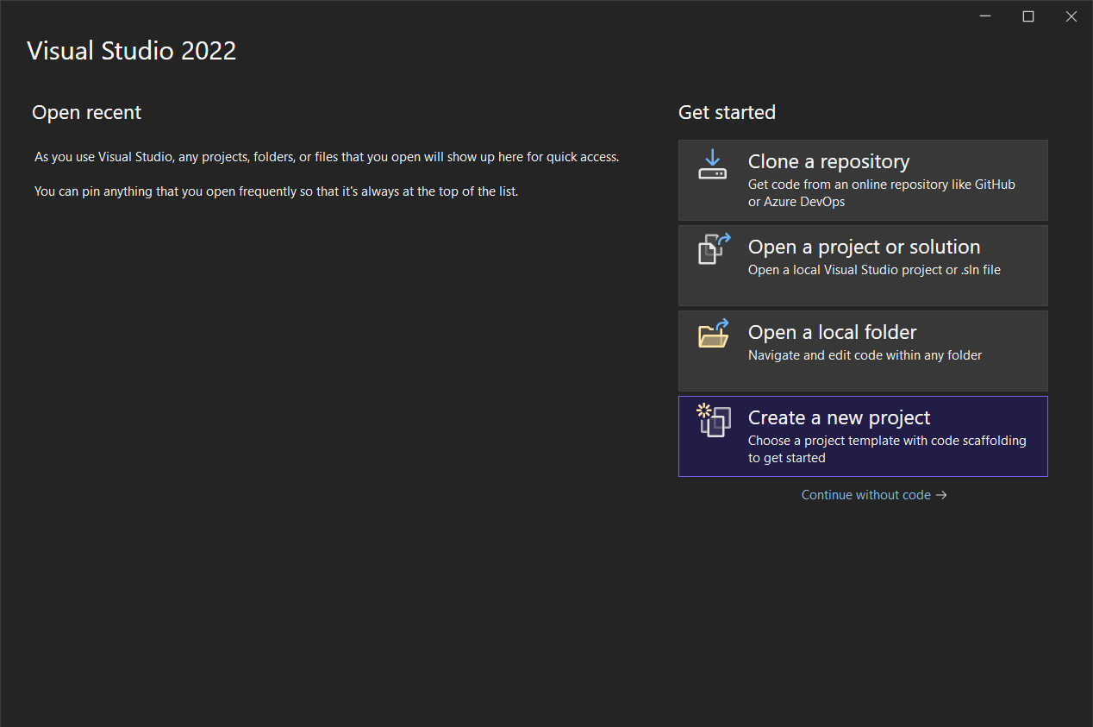

Select the **ASP.NET Core Web App (Model-View_Controller)**

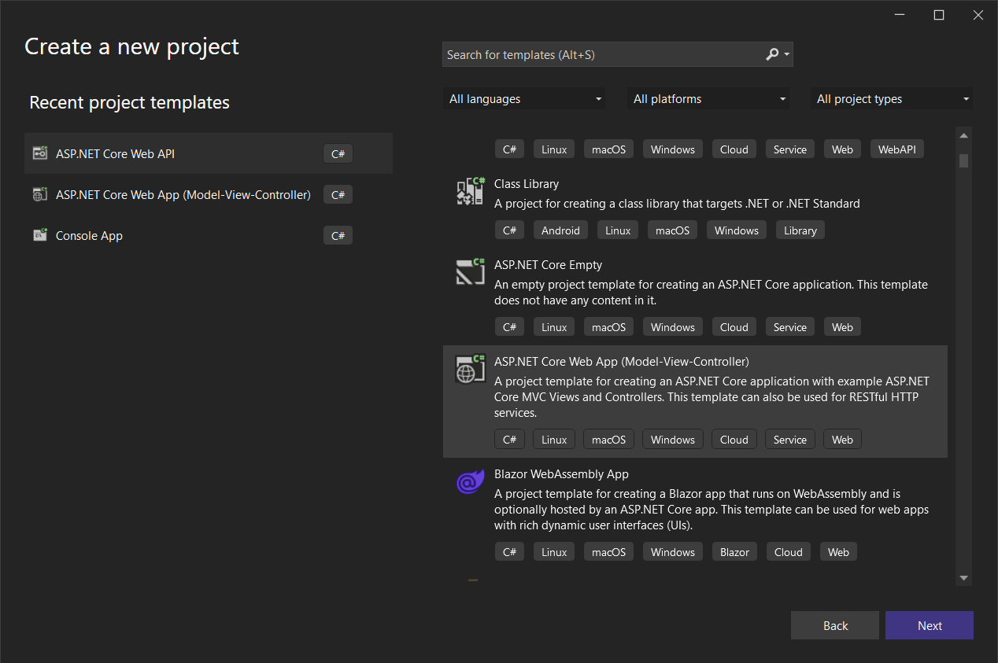

Provide a name to the project:

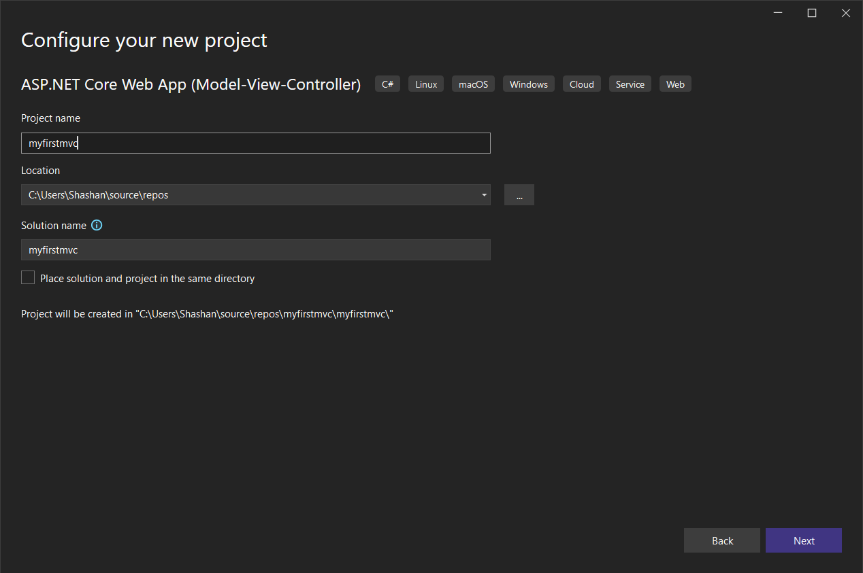

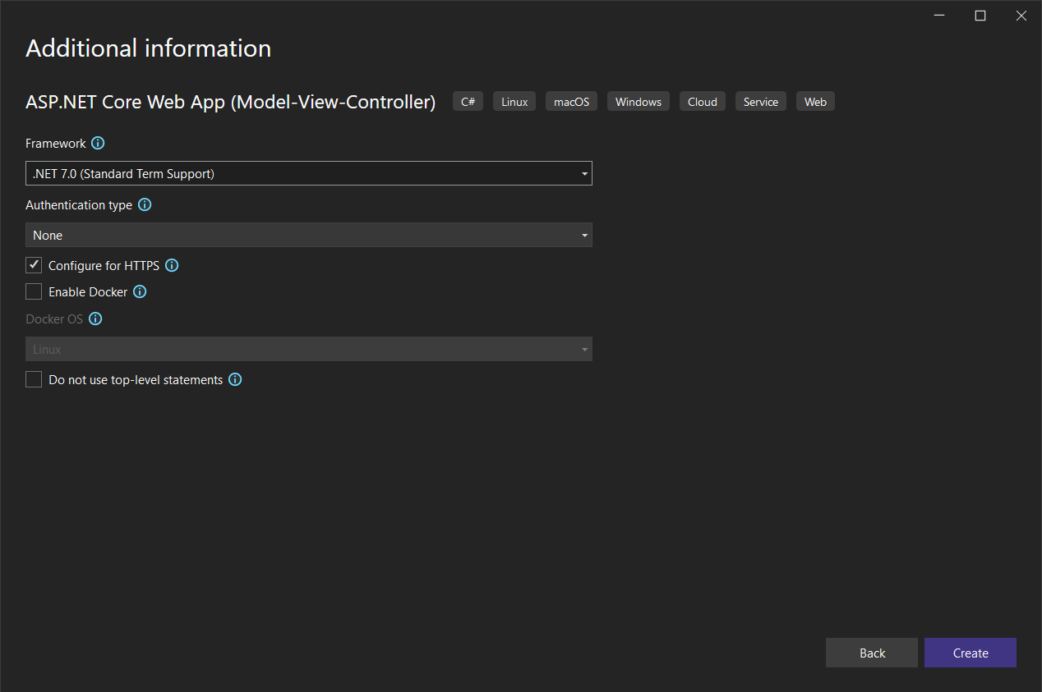

**Code for HomeController.cs under Controller folder:**

using Microsoft.AspNetCore.Mvc;

using myfirstmvc.Models;

using System.Diagnostics;

namespace myfirstmvc.Controllers

{

public class HomeController : Controller

{

private readonly ILogger<HomeController> _logger;

public HomeController(ILogger<HomeController> logger)

{

_logger = logger;

}

public IActionResult Index()

{

return View();

}

public IActionResult Privacy()

{

return View();

}

[ResponseCache(Duration = 0, Location = ResponseCacheLocation.None, NoStore = true)]

public IActionResult Error()

{

return View(new ErrorViewModel { RequestId = Activity.Current?.Id ?? HttpContext.TraceIdentifier });

}

}

}

**Code for ErrorViewModel.cs under Model folder:**

namespace myfirstmvc.Models

{

public class ErrorViewModel

{

public string? RequestId { get; set; }

public bool ShowRequestId => !string.IsNullOrEmpty(RequestId);

}

}

**Code for Index.cshtml under View\Home folder:**

@{

ViewData["Title"] = "Home Page";

}

<div class="text-center">

<h1 class="display-4">Welcome</h1>

<p>Learn about <a href="https://docs.microsoft.com/aspnet/core">building Web apps with ASP.NET Core</a>.</p>

</div>

**Code for Privacy.cshtml under View\Home folder:**

@{

ViewData["Title"] = "Privacy Policy";

}

<h1>@ViewData["Title"]</h1>

<p>Use this page to detail your site's privacy policy.</p>

**Code for Program.cs:**

var builder = WebApplication.CreateBuilder(args);

// Add services to the container.

builder.Services.AddControllersWithViews();

var app = builder.Build();

// Configure the HTTP request pipeline.

if (!app.Environment.IsDevelopment())

{

app.UseExceptionHandler("/Home/Error");

// The default HSTS value is 30 days. You may want to change this for production scenarios, see https://aka.ms/aspnetcore-hsts.

app.UseHsts();

}

app.UseHttpsRedirection();

app.UseStaticFiles();

app.UseRouting();

app.UseAuthorization();

app.MapControllerRoute(

name: "default",

pattern: "{controller=Home}/{action=Index}/{id?}");

app.Run();

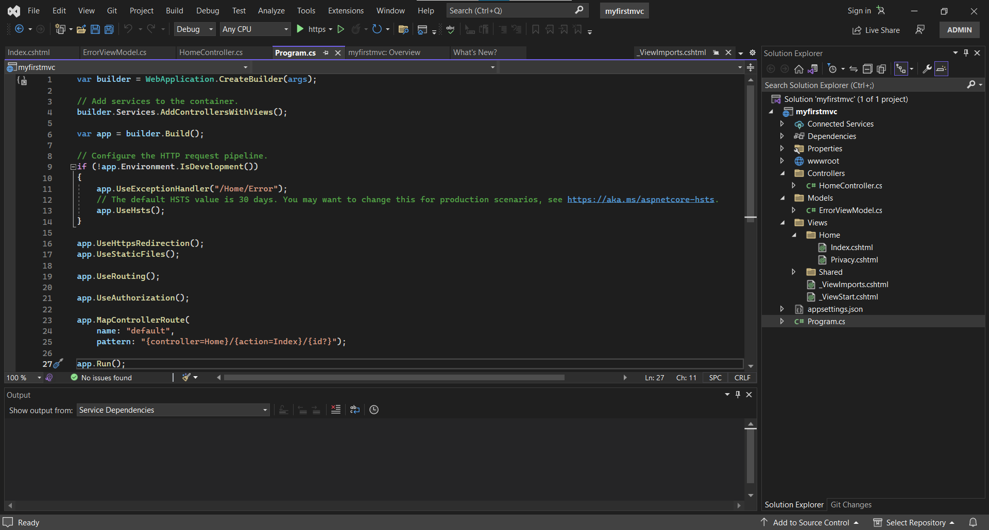

After that click the run project button under the top ribbon

**Output:**

